Research Methods
OCR A Level Component 1

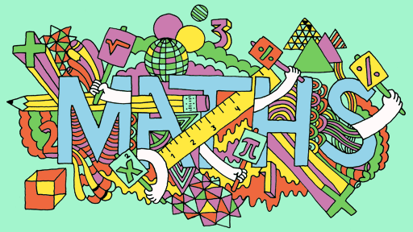

Component 1  Candidates should be able to: - | GREEN | AMBER | RED
1.1
Research Methods & techniques

Experimental method: Lab and field & quasi experiments
Observational techniques: Structured and unstructured, naturalistic, controlled, overt, covert, participant
Self-report: Questionnaires and interviews- Structured, unstructured and semi-structured
Correlations: Analysis of the relationship between co-variables, positive, negative and no correlation
1.2 Planning and conducting research
Scientific processes

Aims & research question
Hypotheses; directional and non-directional, alternative & null
Sampling: Random, snowball, opportunity, self-selected
Variables: Independent and dependent, extraneous variables, operationalisation of variables
Control: Standardisation, counterbalancing and randomisation
Experimental Designs: Independent measures, repeated measures and matched pairs designs
Observational Design: behavioural categories, coding frames, time and event sampling
Designing Self-reports: - Open questions, closed questions, rating scales (likert and Semantic differential rating scale)
1.3
Data Handling and analysis

Raw Data:- raw data recording tables, standard and decimal form, significant figures and estimations
Quantitative and qualitative data
Primary and secondary data: including meta-analysis
Levels of measurement: - Nominal, Ordinal and Interval
Descriptive statistics: Measures of central tendency, Measures of dispersion,
Ratios, fractions and percentages
Graphs & Charts
1.3
Inferential Statistics

Normal & Skewed Distributions
Probability & Significance levels
Using critical values tables
Criteria for using parametric tests
Criteria and understanding for using non-parametric tests: - Mann-Witney, Wilcoxon, Chi-square, Binomial Sign Test and Spearman’s Rho
Type I and Type II errors
1.3 Methodological Issues
Representativeness & Generalisability
Reliability – Internal, external, Inter-rater, test-retest and split half
Validity – Internal, Face, Construct, Concurrent, Criterion, External, Population, Ecological
Demand characteristics, social desirability, researcher bias
Ethics: - Respect, Competence, Responsibility and Integrity
1.4 & 1.5 Report Writing and Practical activities
Sections of a report: - Abstract, Introduction, Method, Results, Discussion, References and Appendices
Citing Academic references
Peer Review
Experience of practical activities: - Self-report, Observation, experiment and correlation
1.6 How Science works
Psychology as a Science
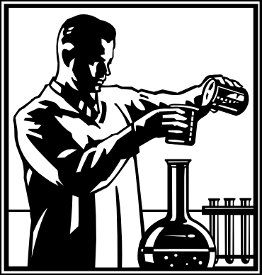
Experimental Methods

Methods such as observation and self-reports do their best to observe and record people’s behaviour, but do not interfere with it in any way or attempt to manipulate the situation. Experiments on the other hand do just that. They deliberately set a situation up and then watch and record what happens. In experiments the psychologist first puts forward an alternative or experimental hypothesis; this is the statement they wish to test. A hypothesis is a prediction, what is expected to happen. An experiment also requires a null hypothesis. This simply states that the results obtained were due to chance and not the independent variable that the researcher changed or the situation that they engineered.

E.g. Alternative or Experimental hypothesis: - Alcohol will increase reaction times
Null Hypothesis: - Any effect of alcohol on reaction times is due to chance.

Things that are manipulated or changed by the psychologist (the cause) are called Independent Variables (IV), in the above example alcohol.

The thing that changes (the effect) as a result of the independent variable, the variable that is measured by the psychologist is called the Dependent Variable (DV), in the above example reaction times.

However, IVs and DVs must be fully operationalized this means stated in a measureable form.
e.g.
IV = Alcohol – measured in units
DV = Reaction times - measured by how fast a person hits the screen when they perceive a hazard on a driving simulator.

Identify the Independent Variable (IV) & Dependent Variable (DV) in the following hypotheses: -

- Participants who have drunk 4 pints of beer will perform worse on a co-ordination test than those who have drunk none.

- Pupils at Snotty Grammar School pass more GCSE’s than pupils at Sink Comprehensive.

- There will be a difference between genders (males and females) in their scores out of 25 on a memory word list test.

- In a memory test participants shown words and images will recall more, than those just shown words.

- Extroverts go to more parties than introverts.

- Participants will complete a jigsaw task faster when they have an audience (of 5 people).

- Being in a stable relationship (happily married or co-habiting) affects mental health (measured on a self-report rating scale of 1-10, 1 = very poor mental health, 10 = excellent mental health).

- Watching violence on TV leads to higher scores on an aggression questionnaire.

- Taking steroids increases levels of strength (measured on a grip test).

- Dogs trained using a reward system will learn to retrieve an object faster (measured in hours of training) than those trained using punishments.

An experiment on teaching rats

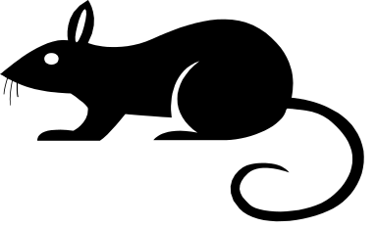
An experimenter noticed that some of her laboratory rats twitched their whiskers whenever their food was brought into the laboratory. She decided to test whether she could teach rats to twitch their whiskers when she flashed a light. First she measured the exact amount of whisker twitching that went on when the food was brought in. Then she flashed a bright light on/off just before each meal. The rats soon started to twitch their whiskers when they saw a light.

- What 2 independent variables are being controlled here?

- What is the dependent variable and how is it measured?

- Why did the experimenters measure the rat’s movements before flashing the light?

- Write a suitable alternative or experimental hypothesis for this experiment.

Formation of hypotheses

To recap, define the following terms: -

Alternative or Experimental Hypothesis: -

Null Hypothesis: -

There are two types of hypothesis, directional and non-directional, also referred to as one-tailed and two-tailed, respectively for the purpose of statistical testing.

A directional or one-tailed hypothesis predicts the direction in which change is expected to occur. Used when previous research has suggested the direction of change. It is precise and uses words such as: - faster/slower, bigger/smaller, more/less etc. e.g. Alcohol increases reaction times.

A non-directional or two-tailed hypothesis simply predicts change and does not specify direction. Used when there is no previous research. It is non-specific and uses words like: - effect, change, difference etc. e.g. Alcohol will affect reaction times.

Task: - Identify the Independent Variable (IV), the Dependent Variable (DV) for each of the following hypotheses and state whether it is directional or non-directional.

- Drinking 5 units of alcohol affects reaction time, measured on a driving simulator.

- Men who have beards are perceived as older than clean-shaven men.

- The quality of beer (rated on a scale of 1-5, 1= poor, 5 = excellent) affects bar takings.

- Boys will score higher on an aggression questionnaire than girls.

- Watching tropical fish helps you relax, measured on a self-report scale of 1-5, 1 = not at all relaxed, 5 = very relaxed.

- The faster you type, the more mistakes you make.

- Individuals are more likely to agree to a suggestion that they previously objected to, in groups of five or more than in pairs.

- Anxiety, measured on a self-report scale of 1-5 (1 = extremely anxious, 5 = not at all anxious) affects the level of adrenaline in the blood.

Practice Writing Hypotheses

A researcher is interested in whether caffeine affects memory. He gives one group of participants a can of coke then 30 minutes later he gives them one minute to learn a list of 15 everyday words and then sees how many they can write down. He repeats this procedure with a different group who are given caffeine free coke.

What are the two conditions of the IV?

What is the DV and how is it measured?

Fill in the gaps

Alternative Hypothesis: - “There will be a significant difference in the ______________________________________ participants who _______________________drank compared to participants who drank___________________________ .

Null Hypothesis: - “There will be no significant difference in the ______________________________________ participants who _______________________drank compared to participants who drank___________________________ .
Any difference is due to chance.

Using these examples as writing frames, identify the IVs and DV in each of the following and write an appropriate Alternativive and Null Hypothesis.

- A researcher is investigating how well Police officers recall number plates compared to non-Police officers by showing a slideshow of 10 number plates, then 5 minutes later they had to write down as many as they can remember. To get a point the number plate must be recalled exactly.

- A researcher is comparing the time taken to complete a lap of a driving obstacle course of male and female participants.

- A researcher is comparing the number of guilty verdicts given in a mock burglary trial based on the area the accused is from. In one condition the defendant (an actor) has a Yorkshire accent and in the other condition the same defendant, in the same clothes, giving the same evidence, speaks with a Liverpudlian accent.

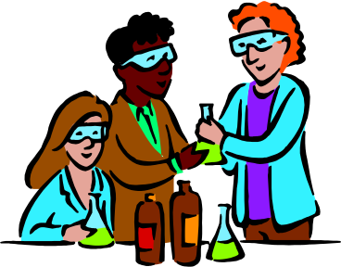
Types of Experiment

- Laboratory Experiment

This method provides the psychologist with the highest possible level of control. The experiment takes place in a controlled environment, this controls situational variables. An example of a laboratory study is Loftus & Palmer’s study on the effect of leading questions on memory.

Advantages | Disadvantages
- Complete control over variables | - Loss of validity (Ecological Validity)
- Forces pace of research | - Drawbacks of experimental design (Experimental or internal validity)
- Easy to replicate (Reliable) | - Demand Characteristics
- Quantitative data | - Sampling Bias
- Able to use technical equipment | - Ethics

- Field Experiments

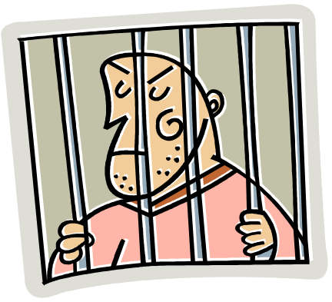
The main criticism of laboratory experiments is that they do not accurately reflect real life. Field experiments try to rectify this problem by carrying out research in a natural environment. An example of a field experiment is Pilliavin’s, Subway Samaritan Study.

Using the advantages and disadvantages of laboratory experiments as a guide, fill in the following evaluation table for field experiments.

Advantages | Disadvantages

- Quasi Experiments

The researcher in a quasi experiment does not directly control the independent variable. The researcher simply exploits naturally occurring differences. For example, if the IV is age or gender. Strictly speaking, therefore this method is not experimental.

Advantages | Disadvantages
- Reduction of demand Characteristics  - Lack of direct intervention | - Loss of control over variables

Extraneous variables

These are other factors apart from the independent variable that can affect the outcome of an experiment (the dependent variable).
The most common being Demand Characteristics, Social Desirability and Investigator effects.

Demand Characteristics: - A demand characteristic is a subtle cue that makes participants aware of what the experimenter expects to find or how participants are expected to behave. Demand characteristics can change the outcome of an experiment because participants will often alter their behaviour to conform to the experimenters expectations.

Social Desirability: - This occurs when the participant changes their behaviour or answers in order to look good. For example, if a teacher asks a student how much they revised over the weekend they will give what they think is a socially acceptable answer and portrays them in the best possible light.

Investigator Effect: - Also known as researcher bias. This occurs when the researcher in some way influences the outcome of the research. This may occur because of something they say or do (body language) or it may be a result of their own expectations. For example, if they are investigating aggressive behaviour in boys and girls and expect boys to be more aggressive, they are more likely to notice and record examples of aggressive behaviour in boys than girls.

The two further main types are situational variables and participant variables.

Situational Variables – These are outside influences on the experiment such as time of day, weather, noise, type of room experiment takes place in etc.
e.g. if you were trying to test a person’s ability to complete a jigsaw puzzle on their own as compared to when in competition with someone else. If the experiment took place at the end of the day, the person could be tired and therefore unable to perform to the best of their ability. Another situational variable could be the noise in the room where the experiment was done.

Control of situational variables: -

- Standardisation All instructions given to participants, procedures followed, scoring techniques and environment must be identical for all participants tested.

Order effects such as practice, boredom and fatigue often occur when a participant is asked to undertake a task more than once (e.g. the control and experimental condition in a repeated measures design experiment).

Reduction of order effects: -

- Counterbalancing As used in a repeated measures design (see below). The researcher changes the order of the tasks for each participant or uses the ABBA technique. For example, in an experiment testing the effect of alcohol on reaction times, half of the participants would be tested first without alcohol and then with and the other half first without alcohol and then with. This technique controls for order effects.
- Randomisation Order of tasks, presentation of data etc. is decided on the toss of a coin or another random method of selection to control for order effects. E.g. In a study (Murstein) that involves rating pictures for attractiveness, the first picture shown is likely to be give an average rating, because participants tend to rate the first picture conservatively in order to save more extreme ratings for subsequent pictures.

Participant Variables are individual differences between participants such as levels of intelligence, age, gender, social class, fitness etc. A researcher can do little to control these, but careful selection of participants can reduce these. Repeated measures designs eradicate participant variables, but lead to order effects. Matched pairs designs minimise participant variables, but even twins have some differences that could be significant.

Experimental Design

Most experiments compare two groups of participants, a control condition and an experimental condition. There are three ways of assigning participants to groups.

- Repeated Measures Design

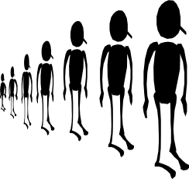

Condition A (Experimental Condition) Condition B (Control Condition)

A repeated measures design involves using the same participants in each condition of the experiment e.g. giving a group of participants a driving test with no alcohol and at a later time the same test after a pint of lager.
Below is a table giving the major advantages of this type of design, what do you think the disadvantages are?

Advantages | Disadvantages
- Controls for individual differences
- Need fewer participants

Independent Measures Design




Condition A (Experimental Condition) Condition B (Control Condition)
An independent measures design involves using different participants in each condition of the experiment e.g. giving one group of participants a driving test with no alcohol and a different group of participants the same test after a pint of lager.
Sometimes this design selects it self if the independent variable is, for example, gender or age, and then obviously males would be in one condition and females in the other.

Fill in the following evaluation table: -

Advantages | Disadvantages

- Matched Pairs Design

A matched pairs design involves using different but similar participants in each condition e.g. twins. An effort is made to match the participants in each condition on any important characteristics that might affect performance e.g. driving ability, alcohol tolerance etc.

Fill in the following evaluation table: -

Advantages | Disadvantages
Identify an appropriate Experimental design for each of the following studies.

Study | Experimental Design?
A study to see if there is a difference in the ability of grey and white rats in learning to run a maze.

A study to investigate whether a twin-born first is more confident than a second-born twin.

A study to see if watching violent
television programmes is likely to
make children aggressive.

A study to investigate whether people are more likely to make a risky decision when they are in a group than when they are alone.

Research into finding a cure for fear of spiders, comparing a treatment group with a non-treatment group.

An investigation into whether people prefer gin and tonic or vodka and lime.

Naturalistic Observation
In this method people are studied in their natural environment. The researcher does not interfere in any way. They are usually looking for particular types of behaviour e.g. aggression being shown or body language etc.

Structured Observation The researcher decides in advance what sort of behaviour they are looking for and devises an observation checklist to complete during the observation. This type of observation generates quantitative data (numbers) usually in the form of a tally chart and is therefore easy to analyse, however this structure can lead to research bias (when the researcher sees what they want to see, not necessarily what actually happens). It is also quite difficult to decide in advance what will be counted as an example of the behaviour being studied, e.g. what counts as aggression. This is known as an Operational Definition. Often a coding system is devised to aid the recording of data, e.g. if you were observing rats you could label sniffing S, Whisker twitching WT, Eating E etc. In this type of observation where certain behaviours are targeted it involves Event Sampling. Event Sampling is simply keeping a count of each time a particular behaviour occurs. In Time Sampling the observer decides on a time interval, such as once a minute, and notes any behaviours displayed during that time interval.

Unstructured Observation In this type of observation the researcher simply records all the action. The data generated can be quantitative (numbers) or qualitative (descriptive, words). This is useful as a first step in research, but it can be difficult to accurately record all that happens. Using two observers (inter-rater reliability) increases the accuracy of the observation, however these observers must be trained in the same way and achieve an agreement level of 80% in order for inter observer reliability to be achieved.

Covert Observation (Under cover) Participants are unaware they are being observed and this reduces demand characteristics, participants act naturally. However, participants have not given consent and therefore it is unethical. Care must be taken not to invade participant’s privacy, as a general rule it is permissible to observe people in a public place, where they could reasonably expect that others may witness their behaviour. However, in psychological research you are not allowed to record observations using video or audio equipment without the participants’ consent.

Overt Observation (In the open) Participants are aware they are being observed. This is obviously more ethical, but leads to demand characteristics (remember how your teachers’ behaviour changed when they had an Ofsted inspector in the room).

Participant Observation The researcher is part of the action they are observing. This is a more natural arrangement, but it is difficult to take notes whilst joining in. Another issue with this type of observation is researcher bias; it is likely that the researcher will influence the action-taking place.

Complete the following tables: -

Covert Observation
Advantages | Disadvantages

Overt Observation

Advantages | Disadvantages

Participant Observation

Advantages | Disadvantages

Structured Observation

Advantages | Disadvantages

Unstructured Observation

Advantages | Disadvantages

Task: -

For homework I would like you to undertake a small-scale observation. Observe any examples of social action for a 10-minute period. You might want to observe your family or friends, people on the bus, etc. anything you want really. You will need to decide if you are going to do a structured or unstructured observation and whether it will be an overt, covert or participant observation and you will need to justify your choice.

Write your observation up in the form of a report, under the following headings: -

Aim: - What you expect to find.
Procedure: - How you carried out your research, including choice of method, justification etc. You might find it useful to draw a diagram of the area where you were observing. Who did you observe (but remember confidentiality, don’t use names, just a description and then Miss X, for example)?
Findings: - What did you find? If you did a structured observation you should have some numerical data that you could display in a graph or chart or if unstructured a description of events.
Conclusions: - What do your findings tell you, how do they relate to your original aim?
Criticisms (Evaluation): - What went well with your observation? What went wrong? What would you change if you were to repeat it? Remember to discuss ethics.

Due Date: -


Self-report

Surveys and self-report studies involve asking participants questions. These can be written in the form of a questionnaire or asked, orally, an Interview.
Any survey is only ever as good as the questions asked. It is very difficult to write good questions and all surveys need a pilot study (a practice run) to check that the questions are unambiguous and easy for participants to understand. This increases the reliability and validity of the data collected. The main problem with surveys is that participants may lie (demand characteristics). Surveys can also be affected by researcher or investigator effects. This is when the researcher influences the participants, often unconsciously. For example, body language such as nodding or smiling could encourage the participants to answer in a particular way. However, surveys are a very efficient and ethical manner of collecting data.

Questionnaires are always structured, but interviews can be structured, semi- structured or unstructured depending on how much of a script you have.

There are four main types of questions: -

Open Questions
Open-ended questions allow participants to elaborate on their answers and give more detail. They generate qualitative data, however they are difficult to analyse.

E.g. how much alcohol do you drink in a week?
How would you criticise this question, what is wrong with it, how could it be improved?

Closed Questions
These types of questions force participants to choose an option. They are easy to analyse and generate quantitative data, but lack detail.

E.g. how many alcoholic drinks do you consume in an average week?
- Less than 10
- Between 10-20
- Between 20-30
- More than 30
How would you criticise this question, what is wrong with it, how could it be improved?

Contingent Questions
These questions depend on the answer to the preceding question.
E.g. do you drink alcohol? Yes/No
If yes go to question 5, if no go to question 3.

Likert Scaling
This type of question generates quantitative data, by assessing strength of opinion. Participants are asked to rate their feelings on a particular topic using a scale. e.g. 1-5.
The example below is a semantic differential rating scale as it uses terms that are polar opposites e.g. agree/disagree. A pure likert scale just uses numbers
e.g. Capital punishment should be reinstated.
____Strongly agree _____Agree _____Neutral _____Disagree ____Strongly disagree

However, the problem is that participants tend to opt for middle values.

Surveys, particularly questionnaires, are useful for gathering large amounts of data, as they are the least time consuming method. Surveys tend not to be used by child psychologists as there are problems of understanding. The best questionnaires tend to use a variety of types of questions. Interviews allow the researcher to elaborate on questions and form a relationship with the participant. However, this can lead to researcher bias and increased demand characteristics. Interviews are also difficult and time consuming to analyse.

Pitfalls to avoid when writing questions: -

⦁ Overuse of jargon e.g. Do you know anyone that is protanopic?
⦁ Emotive language e.g. Do you approve of the oppressive uniform policy
of this school?
⦁ Leading questions e.g. Now that you know how bad smoking is for you,
will you give up?
⦁ Double-barrelled questions e.g. What is the fastest and cheapest way to get to London from here?
⦁ Double negatives e.g. Would you agree that Kim Kardashian is not unattractive?

(Very Dodgy) Eating Questionnaire

Sandy wants to know whether people understand and follow the calorie guidance figures that the government produces and also whether, despite knowing the guidance figures, they still overeat. The following questionnaire has a few issues!
Go through the introduction and questions highlighting and annotating where the problems lie – consider both ethical issues and issues related to questionnaire design.

Hi

My name is Sandy and as part of my Psychology A level work I am doing a study about people’s eating behaviour. I really hope you will fill this in for me because otherwise I might fail the course! Please don’t just bin this I have spent ages printing it out. Answer every question please and then just give it in at the school office or to your form tutor or even me if you see me.

- Name …………………………………………………………………………………

2. Please state how old you are: -
0–16 18–25 26–35 36–45 46–55 56+

3. Most people say that they overeat – do you think you eat too much?
Yes No

- When are you most likely to eat too much? In the morning -at lunch -at tea time
- How often do you eat too much? Everyday- most days -most weeks
- How many calories should a woman eat? …………………

- How many calories should a man eat? ……………………

- What is your favourite food? …………………………

9. Do you know people who eat too much and are overweight? Yes No
Please name an example………………………………………………………………………………

10. Do you know people who eat too little and are underweight? Yes No
Please name an example………………………………………………………………………………

Thank You
Fill in the following tables: -

Interviews
Advantages | Disadvantages
Questionnaires
Advantages | Disadvantages

Correlations

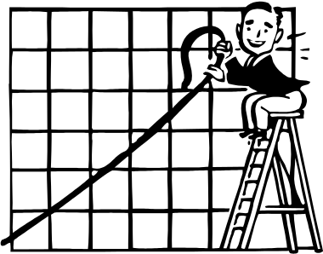
Correlations look for a relationship between two variables. This is not to say that one thing causes another, simply that one thing varies in accordance with another.

For example there is a relationship between the colour of grass and ice-cream sales. The more yellow the grass gets the more ice cream is sold. However, in this case the causal variable is obviously temperature.

Psychologists have suggested a correlation between watching TV violence and aggressive behaviour, this does not suggest that TV violence causes aggressive behaviour simply that there is a relationship between them.
What other variables might cause aggressive behaviour?

Correlations are shown on scatter graphs. Correlation co-efficients tell us about the strength of the relationship. A co-efficient of +1 is a perfect positive correlation, -1 a perfect negative correlation and 0 no correlation. Sketch these three graphs below: -

Positive Correlation +1 | Negative Correlation -1 | No correlation 0

Example of correlational analysis

It is expected that if a person likes the group Blue, they are unlikely to also like Slipknot!

What sort of correlation would this show?

When 10 participants were asked to rate these two groups on a scale of 1-10 the results were as follows: -

Blue | Slipknot
4 | 9
5 | 7
10 | 2
8 | 3
9 | 5
1 | 9
5 | 5
3 | 6
8 | 2
7 | 7

Copy these results into EXCEL and draw a scatter graph, don’t forget the line of best fit. What does your graph show?

We are now to going calculate the correlation co-efficient. Enter the following formula into excel: - =CORREL(A2:A11,B2:B11)
The A2:A11 and B2:B11 refer to the cell references in excel.

What does your correlation co-efficient tell you?

Correlations

Advantages | Disadvantages

Copy each of these sets of results into EXCEL and draw a scatter graph, make sure you label it fully and don’t forget the line of best fit (Click on chart options on the tool bar, add trendline, choose linear).

What does your graph show?

We are now to going calculate the correlation co-efficient. Enter the following formula into excel: - =CORREL(A2:A11,B2:B11)
The A2:A11 and B2:B11 refer to the cell references in excel.

What does your correlation co-efficient tell you? Is there a correlation? Is it weak or strong, positive or negative?

Height (ft) | Shoe Size
5.1 | 3
6.4 | 13
5.8 | 8
5.7 | 6
5.3 | 4
5.2 | 7
6.0 | 10
6.1 | 11
6.2 | 10
5.6 | 5

Length of legs (cm) | Speed of running (Mph)
85 | 19
75 | 18
66 | 22
99 | 18
71 | 17
83 | 16
110 | 15
88 | 12
69 | 17
75 | 10
Attractiveness Rating of Bride (1-10) | Attractiveness Rating of Groom (1-10)
4 | 4
3 | 3
9 | 7
8 | 8
6 | 5
4 | 4
9 | 10
7 | 6
3 | 2

Number of Late Homework (per year) | Score in end of year test (100)
0 | 85
1 | 80
6 | 50
7 | 45
2 | 90
3 | 55
10 | 15
0 | 90
2 | 60
4 | 50

For each of the 4 examples write an appropriate Alternate and Null Hypothesis.

e.g.
Alternate: - There will be a relationship (Positive or negative correlation?) between…………………. and……………………

Null: -There will be no relationship between………………..and…………….Any relationship is due to chance.

Produce a work document with each graph on it and the correlation co-efficient and alternate and null hypotheses underneath.

Task: -

You are going to undertake a piece of correlational research. You will need ten participants. You need to decide what type of sampling technique you are going to use and to justify your choice. Research has shown a correlation between stress and illness (Holmes & Rahe).

What type of correlation would you expect?

Suggest a suitable hypothesis.

Stress will be operationalised by asking participants to rate their present level of stress on a ten point scale 0 = not stressed 10 = extremely stressed.

Illness will be operationalised by the number of days absent from school or work due to illness in the 6 months.

When you have collected your data, write up your research under the following headings: -

Procedure: - How you carried out your research – Sample, where, when, how etc.
Findings: - (Include a scattergraph and a correlational co-efficient)
Conclusion: - What do your findings mean?
Evaluation: - What was good and bad about your research? What would you change if you were to repeat it?

Due Date:

Selecting Participants (Sampling)
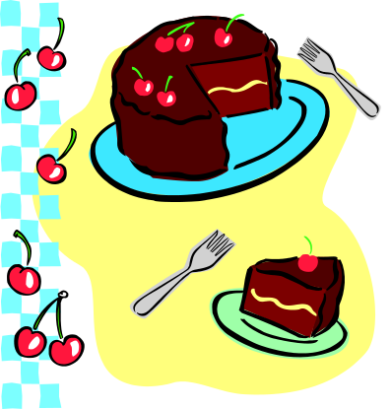

Sampling is the process of selecting participants to study from the target population (a specified section of humankind). Since the results of the study on the sample will be generalised back to the target population (through inference) samples should be as representative (typical) of the target population as possible. Samples should be of a sufficient size to represent the variety of individuals in a target population, but not so large as to make the study uneconomical in terms of time and resources.

Random Sampling Like the National Lottery, all members of the target population must stand an equal chance of being selected. Random sampling does not guarantee a representative sample, but the laws of probability predict that the chances of selecting a biased sample are minimal.
For example: -
Putting the names of every member of the target population into a hat and pulling a sample out (without looking!).

Advantages | Disadvantages

Opportunity Sampling also known as Convenience Sampling most samples in A level coursework are selected in this way. It is the simplest form of sampling and involves selecting anyone who is available from the target population. An effort may be made not to be biased, by selecting equal numbers of males and females, for example.

Advantages | Disadvantages

Self-Selected Sampling Participants volunteer. A good example of this would be Milgram’s obedience experiment. However, sometimes participants do not consciously volunteer. For example, passers by who become involved in field studies i.e. in bystander intervention studies.

Advantages | Disadvantages

Snowball Sampling

Participants are found who fit the criteria for the research. These participants are then asked to introduce family or friends who also fit the criteria. Often used if the population is difficult to access e.g. gamblers, alcoholics, drug users etc.

Advantages | Disadvantages

For each of the following identify the target population and suggest an appropriate sampling technique.

Study | Population | Sampling Technique
An investigation into the attitudes of Eton school students to the new discipline policy.

A study to investigate the effects of separation in infant monkeys.

Research into a cure for the fear of spiders.

Research into sexuality in university students.

Reliability

Reliability refers to the consistency of a test or procedure. It is important to establish reliability when undertaking research. One aspect of reliability involves assessing the consistency of measurement between different observers (Inter-rater reliability). Another involves achieving consistent measuring instruments when developing tests.

Inter-rater Reliability – Would two observers, experimenters etc. come to the same conclusion or score? (e.g. multiple-choice questions would have high scorer reliability; essays might be lower as there is an element of interpretation.) Both researchers must be trained in the same way and in order to establish reliability there must be an 80% concordance rate (agreement) between the two researchers.

Test-retest – Would the results be consistent in a second test?

Split-half – Are scores from the first half of a test consistent with those from the second half of the test. This is not suitable if the test is not of an equal difficult throughout e.g. gets harder or easier.

Internal Reliability is the consistency of the test or experiment itself.

External reliability is the extent to which the results would be the same if the test was repeated.

Measuring Validity

Measurements and findings are valid if they are accurate. How realistic is the study, does it compare to real life?

Face Validity – Does it look OK? Would common sense tell us that the test should work?

Concurrent Validity – Compares two methods of testing to see if results are comparable. Often used to compare a new test with an established one. E.g. new A level system with old AS/A2 level system.

Ecological Validity – Can the findings of research be generalised to other settings beyond the laboratory e.g. would it work in real life.

Construct Validity-The extent to which something actually measures what it proports to measure.

Criterion Validity – Includes both concurrent validity and predictive validity. Predictive Validity – Predicts future performance with some accuracy e.g. GCSE results predict possible A level results.

Population Validity – Refers to how well the results of research can be extrapolated to the population.

The greater number of ways a test has been shown to be reliable and valid, the more confident we can be when using it as a research tool and the more confident we can be about our results and conclusions.

Task: -
Questions on reliability and validity.

- A Level grades are used by Universities. Why? What type of validity does this display? What are the possible problems with this?

- What are the problems involved in using test-retest reliability?

- When could you use face validity? Give an example.

- Define the terms reliability and validity in your own words.

Types of data

Primary data: - Data collected directly by the research, the results from research studies.

Secondary data: - Data that already exists, but is then analysed by the researcher e.g. official statistics.

Task: - Complete the evaluation table

Primary data |  | Secondary data
+ | - | + | -

Meta-analysis: - Involves combining both primary and secondary data to come to an overall conclusion. It looks for similarities and differences in the data. This combines the strengths of both primary and secondary data. Meta-analysis is closely linked to the concept of triangulation which improves the reliability and validity of research findings by using more than one research method or source of data.


Data Analysis

Data can be: -

Quantitative – Numbers
Qualitative – Descriptive (words)
Ordinal – Scores that can be placed in rank order (1st, 2nd, 3rd etc.)
Nominal – Frequency (e.g. %)

Measures of Central Tendency

Hopefully you remember these from GCSE Maths!!
To Recap: -

Mode – the most frequently occurring value
Median – the middle value when scores are arranged in descending order
Mean – the arithmetic average (add up all scores and divide by the number of scores)

Calculate the mean for the following data set

1
2
5
9
1
7
6
4
3
8
Mean

The Mode can easily be calculated by eye, but remember a set of scores can have more than one mode and all scores can be modal if no score is repeated. The most common use of the mode in everyday life is clothes sizes, these are the most popular sizes e.g. 10, 12, 14, 16 etc. or waist sizes 28, 30, 32, 34 etc.

The Median can be calculated by sorting the scores into order and then finding the middle value. If two scores are in the middle, the median is calculated by adding the two scores up and dividing by two.

e.g. 1,1,2,3,4,5,6,7,8,9,

Median is between 4 and 5, therefore it is 4.5

Calculate the mean, median and mode of the following sets of scores.
.

  - 4 5 5 7 7 8 9 10 12 15 17 Mean = Mode = Median =
  - 12 20 31 35 39 48 55 71 85 Mean = Mode = Median =
  - 2 14 5 12 7 Mean = Mode = Median =
  - 25 53 37 17 62 93 41 27 33 19 Mean = Mode = Median =
  - 1.5 1.7 1.8 1.9 2.0 2.0 2.1 2.2 Mean = Mode = Median =
  - 4 5 5 7 7 7 8 9 9 10 12 12 12 12 13 Mean = Mode = Median =
  - 26 27 29 25 31 33 27 32 28 27 33 Mean = Mode = Median =
  - 3 5 1 6 2 5 4 8 1 5 7 2 1 5 4 3 6 9 4 1 6 7
Mean = Mode = Median =

What are the advantages and disadvantages of each of these measures of central tendency?

Mean |  | Median |  | Mode
+ | - | + | - | + | -
Measures of Dispersion

These examine variability in data sets. They help us understand whether scores in a data set are very similar or very different. In other words how spread out scores are.

Range – This is the simplest measure of dispersion. It tells us over how many numbers a distribution is spread. It is the difference between the highest and the lowest score. The problem with this is that extreme values affect the result.

e.g.
10 11 11 12 12 13 13 13 14
10 11 11 12 12 13 13 13 20

One single figure changes the range from 4 to 10.

Calculate the range for the following data sets and comment on what it tells us.

- 12 10 8 4 18 8
- 0 0 4 5 20 22 19
- 0 19 21 18 22
- 2 3 3 3 4 4 4 4 5 5 5 6

Standard Deviation – This is a much more useful measure of dispersion, as it tells us how far, on average, each score is from the mean. The smaller the standard deviation the more scores are clustered around the mean, the larger the standard deviation is the more spread out are the scores.

Those of you who did the higher tier in GCSE maths will already be familiar with the calculations for standard deviation and know it is pretty complicated. But it becomes easy once you break it down.

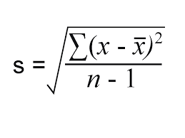

Calculations for Standard Deviation

Raw Data | Score –mean (x-x⁻) | (x-x⁻)²
6 | -1.3 | 1.69
5 | -2.3 | 5.29
1 | -6.3 | 39.69
9 | 1.7 | 2.89
8 | 0.7 | 0.49
6 | -1.3 | 1.69
6 | -1.3 | 1.69
11 | 3.7 | 13.69
9 | 1.7 | 2.89
12 | 4.7 | 22.09
Mean = 7.3 |  | Σ= 92.1

92.1 = 10.233 (Variance)
9

√10.233 = 3.2

sd = 3.2

Calculate the standard deviation for the following data sets and comment on what it tells us.

- 12 10 8 4 18 8 sd =
- 0 0 4 5 20 22 19 sd =
- 0 19 21 18 22 sd =
- 2 3 3 3 4 4 4 4 5 5 5 6 sd =

Interquartile Range – when data is put in order, find the first quartile (Q1) and the third quartile (Q3), simply subtract Q1 from Q3. Notice that the second quartile is the median

E.g. 3, 4, 7, 7, 8, 9, 12, 14, 17, 17, 18

Q1 Q2 Q3

17-7 = 10 (Q3 – Q1 = Interquartile range)
Semi-interquartile range = 10

The advantage of the interquartile range over the range is that it is less affected by outliers (anomalous scores).

If you use the mode as a measure of central tendency, the range is the appropriate measure of dispersion, the mean, standard deviation and the median is paired with the interquartile range.

Graphs


Graphs are pictorial presentations of data. They should be chosen to enable the data to be displayed in the most effective and clear way possible. All diagrams must be fully labelled; care must be taken to select an appropriate scale so the data is not in any way capable of misrepresentation. All graphs should be accompanied by a sentence or two of explanation.

Using excel draw the following graphs, remember to label them and comment on them (What do they tell us?).

Bar Charts

A bar chart is a diagram consisting of columns (bars), the heights of which indicate frequencies, so data on the x-axis is discrete. A histogram is similar to a bar chart, but without gaps between columns, so the data is continuous on the x-axis.

Display the following date in a bar chart.

Children In Family | Frequency
Zero | 8
One | 11
Two | 17
Three | 8
Four | 5
Five | 1

Pie Charts

A pie chart is particularly suitable for displaying how a population is divided up into different parts and what proportion of the whole each portion represents. The bigger the proportion, the bigger the slice of pie!! Pie charts are difficult to draw manually as you have to convert your proportions to proportions of 360 degrees and use a protractor, using excel they become easy. Pie charts are used to display nominal data.

Display the following data in a pie chart: -
Modes of Transport

Walking | 12
Cycling | 8
Bus | 26
Train | 33
Car | 11

Line Graphs (Frequency Polygon)

A Histogram can be replaced by a line graph, in this case the data is plotted as a series of points that are joined by straight lines. It is particularly useful for comparing two sets of data. Data on the x axis must be continuous.

Display the following data in a line graph: -

Month | Jan | Feb | Mar | Apr | May | Jun
Rainfall (mm) | 75 | 192 | 86 | 89 | 25 | 19

Normal Distributions

Intelligence is said by psychologists to be normally distributed throughout the population. This means that if you plotted everyone’s IQ on a graph you would get a bell shaped curve, the average IQ is 100 (Mental age/Chronological age X 100 e.g.17\17 = 1 X 100 = 100), most people’s IQ is between 70 and 130. Height and weight can also be said to be normally distributed throughout the population.

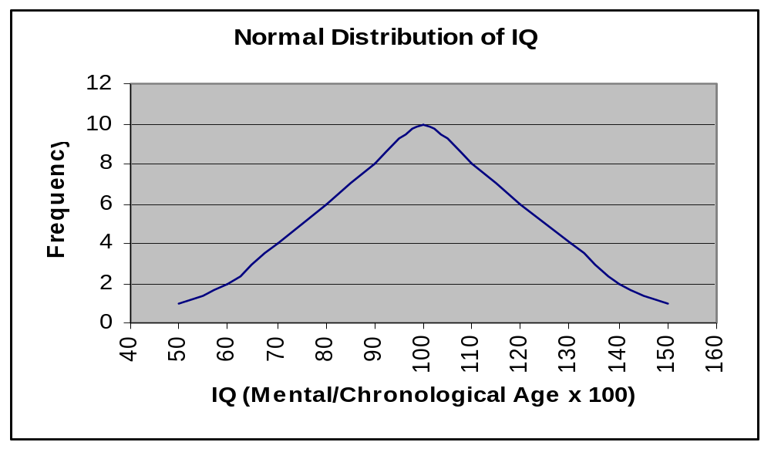
Characteristics of a normal distribution curve, also know as a bell-shaped curve or a Gaussian curve: -

- it is bell-shaped
- it is symmetrical
- the mean, median and mode all fall on the same central point.
- The two tails never touch the horizontal axis.

Plot the following four distributions (4 individual graphs), remember to join up points with a smooth curve. (Use the scattergraph option on Excel) Mark the mode, mean and median on each graph.

A |  |  | B |  |  | C |  |  | D
Marks x | Students y |  | Marks x | Students y |  | Marks x | Students y |  | Marks x | Students y
20 | 10 |  | 20 | 20 |  | 20 | 10 |  | 20 | 20
40 | 15 |  | 40 | 35 |  | 40 | 15 |  | 40 | 30
60 | 30 |  | 60 | 60 |  | 60 | 20 |  | 60 | 40
80 | 45 |  | 80 | 40 |  | 80 | 25 |  | 80 | 30
100 | 50 |  | 100 | 30 |  | 100 | 30 |  | 100 | 20
120 | 45 |  | 120 | 20 |  | 120 | 40 |  | 120 | 20
140 | 30 |  | 140 | 15 |  | 140 | 45 |  | 140 | 30
160 | 15 |  | 160 | 10 |  | 160 | 50 |  | 160 | 40
180 | 10 |  | 180 | 5 |  | 180 | 40 |  | 180 | 30
 |  |  |  |  |  | 200 | 30 |  | 200 | 20

As well as normal distributions, curves can be positively skewed, negatively skewed or bi-modal.

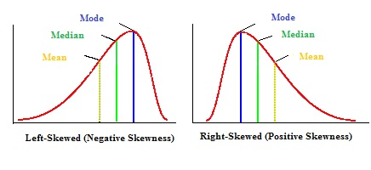
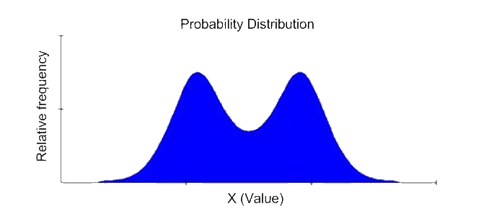

Example: -

A level examinations are designed so that grades are normally distributed e.g. the mean, median and modal grade is a C, with fewer candidates achieving A* or U.

If the distribution was negatively skewed this would mean that more students were achieving the higher grades, than the lower grades and the mean grade might be a B.

In this case what would the exam boards need to do to grade boundaries to ensure a normal distributions of grades?

- make them higher
- make them lower
If the distribution was positively skewed this would mean that more students were achieving the lower grades, than the higher grades and the mean grade might be a D.

In this case what would the exam boards need to do to grade boundaries to ensure a normal distributions of grades?

- make them higher
- make them lower
Standard Form

Standard form is a way of writing down very large numbers easily. E.g. 1000 = 10³ (10x10x10)

Small numbers can also be written in standard form. However, instead of the index being positive (in the above example, the index was 3), it will be negative. E.g. 0.05 = 5 × 10⁻²

The rules when writing a number in standard form are that first you write down a number between 1 and 10, then you write × 10 (to the power of a number)

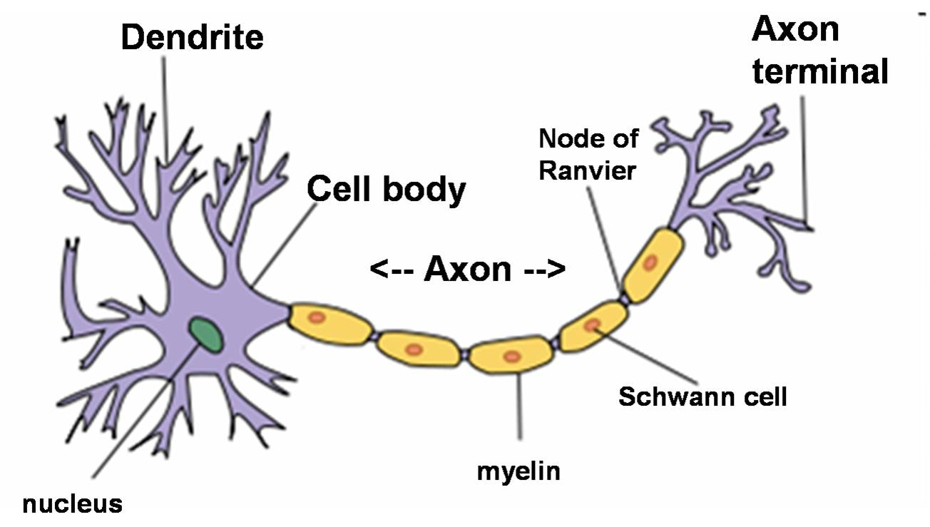
1) The mean number of neurons in the human brain is 100,000,000,000 Express this in standard form

2) One neuron may be as narrow as 0.004 centimeters in diameter. Express this in standard form

Order of Magnitude

Orders of magnitude are used to make very approximate comparisons and reflect very large differences.

For example compare 387 with 40,262,030: -

- 387 is approximately 400 and 40,262,030 is approximately 40,000,000
- Therefore 40,262,030 is approximately 100,000 times bigger than 387

Now you try: -

- Compare 99 with 6789
- Compare 467 with 4,627
- Compare 1899 with 38, 957

ETHICS

ETHICS are standards of conduct that distinguish between right and wrong, good and bad, justices and injustice.

The primary aim of psychology must be to improve the quality of human life and to do this it is necessary to carry out research with human participants. Research psychologists have a duty to respect the rights and dignity of all participants.
This means that they must follow certain moral principles and rules of conduct, which are designed to protect both participants and the reputation of psychology. The professional organisation that governs psychology in Britain is the British Psychological Society (BPS). They have produced a list of ethical guidelines that all practising psychologists must follow.

An ethical issue is any situation that repeatedly gives rise to an ethical dilemma. For example, whether or not to deceive a research participant in a psychological study in order to gain more worthwhile findings is an ethical issue because it creates an ethical dilemma for the researcher. i.e. What should they do? One of the main reasons organisations like the BPS have developed ethical guidelines is that it removes the need for researchers to resolve these dilemmas on their own.

The BPS ethical guidelines

Informed consent
Participants must give their consent to take part in research and this consent must be ‘informed’. This means that information must be made available on which to base a decision to participate or not. Participants should be told what they are letting themselves in for. Only then are they in a position to give informed consent.
To study participants without consent would be ethically acceptable so long as what happens to the participants could just as likely happen to them in everyday life. E.g. observation in naturalistic setting such as bus queues. People in bus queues may be observed by anyone. In the case of young people under 16, consent should also be obtained from their parents.

A major problem with informed consent is the possibility that the researcher will ‘give the game away’ and thus influence participants’ behaviour. As a result, a case can be made for withholding information.

Deception
Deception means that information is withheld from participants; they are misled about the purpose of the study and what will happen during it. According to the BPS guideline ‘Intentional deception of the participants should be avoided whenever possible’. In particular deception is unacceptable if it leads to ‘discomfort anger or objections from the participants’ when the deception is revealed after the research has been complete’.

But, the BPS accepts that sometimes deception is unavoidable. In such cases the researcher must:
  - Make sure that alternative procedures which avoid deception are not available
  - Consult with colleagues about how participants might be affected by the deception
  - Reveal the deception to the participants immediately after the research has been completed.

Protection from harm
The BPS ethical guideline states that ‘Investigators have a primary responsibility to protect participants from physical and mental harm during the investigation’.
But, no investigation is risk free; the guiding principle is that risks should be no greater than the risks participants are exposed to in their normal lifestyles. Participants should be encouraged to contact the investigator after the research if they have any worries or concerns. The investigator has a responsibility to detect and remove any consequences of the research.

Confidentiality: protection from harm involves confidentiality. Participants may be asked personal questions. They must be told that there is no need to answer these questions and, if they do that their answers will be treated in confidence. That is, they should remain anonymous. Invasion of privacy can result in unease or distress. The BPS states that unless people have given their consent, they should only be observed in situations where they would expect to be observed by strangers. This limits observational research to public places.

Withdrawal: Participants should have the right to withdraw from an investigation at any time. This is true even if they are being paid to take part. They should be told this at the start of the research. No attempt should be made to encourage or persuade them to remain.

Debriefing
Debriefing involves telling it all after the investigation is complete. Researchers should discuss the aims of the research with the participants, making sure they understand how they have contributed to meeting those aims. Any deception is disclosed, explained and justified. Attempts are made to undo any negative effects of the research. Codes of conduct for research state that all participants have a right to a debriefing session after the investigation has been completed. But, participants may be reluctant to express negative feelings during debriefing due to embarrassment or not wanting to upset the researcher.

Ethics Task

Look at the following brief descriptions of studies. Decide which you think are real and which are fake. What are the ethical principles that these studies violate?

- In a busy subway, a person collapses bleeding from the mouth. The person is a confederate of the experimenter and the event is staged. Bystanders are covertly observed to see if they help and how long they take to help. An investigation into bystander responses to emergency situations.

- An experimenter in a pick-up truck, with a rifle visible in the back and a sticker on the bumper saying ‘Vengeance’ stops at red lights. The experimenter does not move when the lights turn green thus blocking traffic. This experiment is testing the impact of aggressive stimuli on ‘horn-honking’ behaviour.
- Baby rhesus monkeys reared in complete isolation except for two-surrogate ‘mothers’; one a wire structure with a plastic face, and the other a wire structure but covered with terry towelling. This study is investigating the nature of mother-child relationships.

- Rats are given an electric shock to the feet, and soon afterwards a toy rubber hedgehog flies (on wires) across the top edge of their cage. An investigation into the effects of aversive conditioning.

- Participants are presented with 2,000 sheets of random numbers, asked to add up 224 pairs of numbers on each sheet, and then tear the sheet into 32 pieces before going onto the next. After five hours of this clearly useless task, some of the subjects are still going and have to be stopped by the experimenter. An investigation into the power of the psychology experiment.

- Rats are given electric shocks to the brain after they have learnt a maze to see how this affects their memory of the maze.

- Ammonia is used to punish a deaf-blind five-year-old boy engaging in serious self-injurious behaviour (self mutilation). An investigation based on real life interventions into the relative effects of various types of punishment on self-injurious behaviour.

- Head-banging behaviour is taught to rhesus monkeys, extinguished (got rid of) and then re-established in order to investigate the hypothesis that some forms of self-injurious behaviour are linked to reinforcing features in the environment.

- Electric shock administered to homosexuals as they view photographs of clothed and naked males. An investigation into the treatment of ‘sexual deviations’.

- A hidden observer in a men’s toilet records the time taken before participants begin to urinate and the time they take urinating. A confederate of the experimenter either stands in the next stall to the subject or one stall away. An investigation into the effects of invasion of privacy on arousal.

Fill in the gaps with the words at the bottom of the page

Ethical issues arise in Psychology when there is a conflict between the rights of ......................and the needs of ...................... to conduct research that makes a meaningful contribution to......................

One major issue is that of informed consent. This involves making participants aware of the ...................... and the ...................... of the research and informing them of their ................to withdraw. However, from the viewpoint of the researcher, telling the participant the purpose of the research may render it ...................... as participants will no longer act as they would in
the usual course of their lives. This was a particular issue in the study by ...................... as no participants would have potentially harmed ‘Mr Wallace’ if they knew the purpose of the study.

Informed consent can be a particular problem in ...................... observation studies since participants may have no opportunity to consent.

Deception is another major issue. This may involve simply withholding information from participants or may involve being deliberately ...................... . Deception can be justified if it does not cause undue .............. It is important to do a full ...................... at the end of the study so that participants are aware of the aims and can ...................... their data if they so wish.

A third issue is that of the safety of participants who have the right to be protected from...................... and psychological harm. The latter includes not causing them to feel ......................or feel inadequate as they may have done in the research on conformity by ......................

Privacy and ...................... are two other linked issues. If ...................... details are held they must be protected. If possible it is better to have no such details, that is to maintain......................

Under all circumstances it is important that participants are treated with ...................... and their ...................... maintained.

Right, distress, covert, meaningless, embarrassed, dishonest, participants, Asch, researchers, society, withhold, respect, anonymity, personal, physical, confidentiality, Milgram, debrief, dignity, aims, procedures.

Ethics is all about creating a balance.


What is the balance between?

What is the name of the body responsible for psychology ethics in the UK?

A suggestion for a Mnemonic:

Ethical guidelines suggest what researchers
Can Do & Can’t Do With Participants

Consent Deception Confidentiality Debriefing Withdrawal Protection

Now make up your own – remember the letters can be in any order:

- Dealing with informed consent:
How do you obtain it?

- Three alternative ways of getting consent if it is impractical to get informed consent:

- Dealing with deception and protection from harm.
Using one word or a short phrase, write out three things a researcher should do to deal with these issues:

- Dealing with confidentiality.
Using one word or a short phrase, write out two ways in which researchers can deal with this issue:

Peer Review

Peer review is the evaluation of work by one or more people of similar competence to the producers of the work (peers). It constitutes a form of self-regulation by qualified members of a profession within the relevant field. Peer review methods are employed to maintain standards of quality, improve performance, and provide credibility. In academia peer review is often used to determine an academic paper's suitability for publication.
The reviewer is often asked to make an explicit recommendation of what to do with the manuscript or proposal. Most recommendations are along the lines of the following:
- to unconditionally accept the manuscript or the proposal,
- to accept it in the event that its authors improve it in certain ways,
- to reject it, but encourage revision and invite resubmission,
- to reject it outright.
In Psychology the role of peer review is taken very seriously.
Task: - You are a research psychologist and have recently written up your latest research. You wish to have it published in an academic journal, but first it must go through the process of peer review.
What for you as a researcher is the benefit of peer review?
What is the benefit for the scientific community of psychology?
Are there any potential problems with peer review?
Is there any potential for bias?
Evaluation
Anonymity: - As reviewers are anonymous, they may use this anonymity to unfairly criticize those they hold a grudge against.
Publication Bias: - The file drawer effect. There is a tendency to only publish research which has statistically significant findings.
Burying ground breaking research: - Research that questions or falsifies existing theories will find it difficult to get published as there is a tendency to protect the status quo.
Peers are in competition for scarce funding and publication is important to universities and researchers.
Task: - Read the newspaper article, if you were peer reviewing this, what would your recommendations be? What questions would you ask?
Too many girls studying 'soft option' psychology: Schools should encourage female students to focus on 'hard sciences' so they get top places at university, education leader says
By Sarah Harris for the Daily Mail
Published: 02:18, 19 September 2015

Girls should be persuaded to ditch psychology & switch to ‘hard sciences’
That is the view of Barnaby Lenon, chair of Independent Schools Council.
He said too many girls were taking the subject when they were capable of getting good grades in physics and chemistry instead.
Schools should persuade girls to ditch studying psychology and switch to ‘hard sciences’, an education leader says.
This is making it more difficult for them to gain places on sought-after university courses such as medicine and engineering, he said.
Mr Lenon said that private schools had helped to increase the number of girls studying sciences but this was not mirrored in the state sector.
The problem needs to be addressed in order to bring more women into science, technology, engineering and maths (STEM) careers, he said.
‘Teachers should be saying, you’d be good at physics and it leads to more university degree options than psychology,’ he told the Times Educational Supplement.
‘It’s in the interest of the country as a whole that more pupils should be doing hard sciences and that there should not be a gender imbalance within individual subjects.’
‘Girls who should be doing physics are doing psychology.’
‘It’s a problem for the hard sciences and it’s a problem for the girls who might have the potential to become doctors or engineers.’

But Professor Catriona Morrison of the British Psychological Society said: ‘Discussions that continually polarise science subjects as gender-specific are unhelpful and reinforce stereotypes.
Students chose different subjects for a range of reasons. It is complex and multifaceted.’

Levels of Data

Nominal data: a level of measurement where data are in separate categories (Frequencies).
Ordinal data: a level of measurement where data are ordered in some way. (Interval & Ratio data can be converted to ordinal)

Ordinal data is data that can be place in rank order e.g. 1st, 2nd, 3rd etc.
e.g. Highest gets rank value of 1 etc.

Scores | 37 | 34 | 33 | 31 | 28 | 23 | 21 | 15 | 14 | 13
Rank | 1 | 2 | 3 | 4 | 5 | 6 | 7 | 8 | 9 | 10
Shared Ranks
Scores | 37 | 34 | 34 | 34 | 28 | 23 | 21 | 14 | 14 | 13
Rank | 1 | 2 | 3 | 4 | 5 | 6 | 7 | 8 | 9 | 10
Ranks | 1 | 3 | 3 | 3 | 5 | 6 | 7 | 8.5 | 8.5 | 10

Task: - Rank the following data sets

- 3,4,5,5,6,7,7,9,9,10
- -2, 0,7,-1,3,4,5,8,9,10
- 23,23,23,23,23,21,20,31,28,29
- 27,3,19,45,6,7,9,3,3,27

Interval data /Ratio data: a level of measurement where units of equal measurements (a scale with equal intervals) are used e.g. minutes, kilograms, number of words recalled in a memory test or percentage score in an exam. Ratio data is on a scale, but has a true zero e.g. weight/height, time, distance.

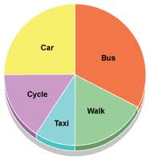

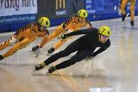


Looking at the 3 pictures above, find examples, of each type of data:

Nominal data | Ordinal data | Interval/Ratio data

Now identify the level of the data in each of these examples:
- Number of children (average age 4.5 years) engaged in type of play
Non-play | Solitary | Associative | Parallel | cooperative
8 | 5 | 17 | 23 | 6

……………………………………………………………………………………………………………………………………

- Podium positions, Monaco Grand Prix 2010
Mark Webber, Sebastian Vettel, Robert Kubica
……………………………………………………………………………………………………………………………………

- Rosenthal and Fode (1963) Time in minutes taken by rats to correctly find their way round a maze.
……………………………………………………………………………………………………………………………………

- Holmes & Rahe devised a stress scale, with arbitrary numerical values given to a series of life events such as ‘death of spouse’ or ‘getting married’
……………………………………………………………………………………………………………………………………
- Bandura’s Bobo Doll study, behaviours observed: aggressive, non-aggressive
……………………………………………………………………………………………………………………………………
- Schacter& Singer (1962) attempted to estimate how emotional Pps were feeling, using a scale to measure happiness, and another to measure anger.
……………………………………………………………………………………………………………………………………
- Collins & Quillian (1969) measured time taken in seconds, to decide if statements were true or false.
……………………………………………………………………………………………………………………………………

- Lang & Lazovik (1963) measured phobics’ scores on a 19-point scale ‘snake avoidance test’.

……………………………………………………………………………………………………………………………………

Inferential statistics

The aim of inferential statistics is to discover if your results are statistically significant. A statistically significant result is one which is unlikely to have occurred through chance. Usually, psychologists use the 5% level (0.05), this means that just 1 in 20 of results could have occurred due to chance. We express our results in terms of the Null Hypothesis, if a result is statistically significant we can reject the null hypothesis, if the result is not statistically significant we must accept the null hypothesis. In other words we need to be 95% confident that the results were due to the manipulation of the IV in order to reject the null hypothesis.

Null Hypothesis: - Any change (difference) between the two conditions is due to chance.

The concept of statistical significance is linked to the mathematical concept of probability.

Task: - Complete the following exercise

On a scale of 1-99 rate the following statements for probability 1 = almost impossible and 99 = almost certain (Remember the only thing certain is death and the only thing impossible immortality!)

- You winning the lottery
- It raining in the next week
- Dreaming of elephants this week
- Having a day off ill this term
- Becoming a famous entertainer
- Becoming a parent in your lifetime
- A cure for cancer being discovered in your lifetime
- If you spin a coin it will come down heads
- If you spin two coins they will both come down heads
- Passing all your A levels

Because we used a scale between 1-99 your answers are expressed as percentages. Convert them into fractions and then decimals e.g. 50% is ½ or 0.5 (50/100 cancelled down to lowest possible) 50% move the decimal point two places to the left)

In psychology the most common level of significance is 5% (e.g. 1 in 20 or p≤0.05) (the p stands for probability and ≤less than or equal to). This level is seen as a representing a balance between a type I and type II error) The 5% level is fine for Psychology, but clearly if we were experimenting on a new drug , a 1 in 20 chance that it might kill you are not very good odds and the level would have to be significantly reduced.

Type I Error | False Positive. Rejecting the null hypothesis, when there is a possibility that the results were due to chance. Often caused by using a significance level that is too lenient e.g. 10%, 0.10, 1 in 10, p≤0.10. Not being cautious enough.
Type II Error | False Negative. Accepting the null hypothesis, when there is a possibility that the results were significant. Often caused by using a significance level that is too strict e.g. 1%, 0.01, 1 in 100, p≤0.01. Being over cautious.

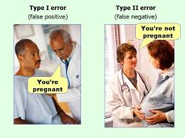

Choosing an appropriate non-parametric statistical test

 | Test of Difference |  | Test of Association
Level of Measurement | Independent Measures Design | Repeated Measures Design or Matched Pairs | Correlation
Nominal (Frequency) | Chi-square | Sign Test | Chi-Square
Ordinal, Interval or Ratio (Ranked) | Mann-Whitney U Test | Wilcoxon matched pairs signed ranks test | Spearman’s Rank Order Correlation Coefficient

After performing the necessary calculations for these tests, you will need to look up your calculated value in the critical value tables (back of handout) to discover if your result is statistically significant. All these tests except the Mann Whitney U and Wilcoxen need a calculated value which exceeds the critical value in order to be significant.

To re-cap: -

Define the following terms and fill in the tables: -

Independent Measures Design |  | Repeated Measures Design |  | Matched Pairs Design
+ | - | + | - | + | -

Spearman’s Rank Order Correlation Coefficient

It is expected that if a person likes the group Guns N Roses, they are unlikely to also like Jedward!
What sort of correlation would this show?
When 10 participants were asked to rate these two groups of a scale of 1-10 the results were as follows: -

Guns n Roses | Jedward
4 | 9
5 | 7
10 | 2
8 | 3
9 | 5
1 | 9
5 | 5
3 | 6
8 | 2
7 | 7

Draw a scatter graph; don’t forget the line of best fit. What does your graph show? Then rank the scores.

Guns n Roses | Rank 1 | Jedward | Rank 2 | d | d²
4 | 3 | 9 | 9.5 | -6.5 | 42.25
5 | 4.5 | 7 | 7.5 | -3 | 9
10 | 10 | 2 | 1.5 | 8.5 | 72.25
8 | 7.5 | 3 | 3 | 4.5 | 20.25
9 | 9 | 5 | 4.5 | -4.5 | 20.25
1 | 1 | 9 | 9.5 | -8.5 | 72.25
5 | 4.5 | 5 | 4.5 | 0 | 0
3 | 2 | 6 | 6 | -4 | 16
8 | 7.5 | 2 | 1.5 | 6 | 36
7 | 6 | 7 | 7.5 | -1.5 | 2.25
 |  |  |  | Σd² | 290.5

Rs = 1 - 6Σd²
n(n²-1)

Rs = 1- 6x290.5
10(10²-1)
Rs = 1 – 1743
990

Rs –= 1 – 1.76

Rs = -0.76

Look up the results in the critical value tables N =10, significant level = 0.05, 5%. (nb. The – or + simply tells you whether it is a positive or negative correlation)

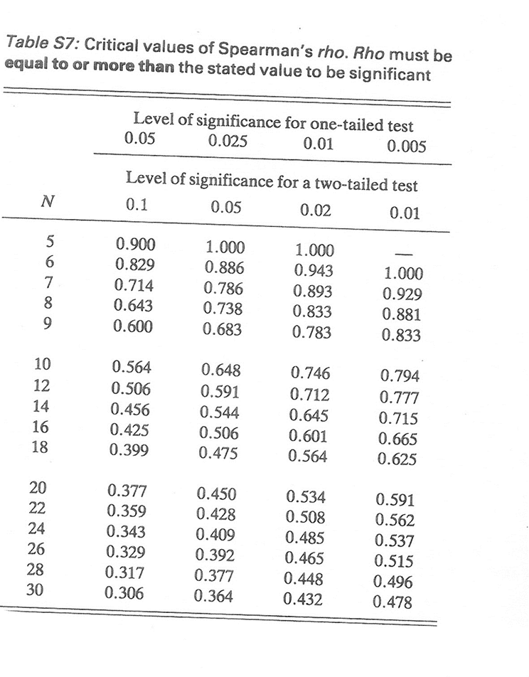

Sign Test

This test simply involves counting up the number of positive and negative signs.

Example: -

A study was conducted to discover if students changed their attitude towards the death penalty after watching ‘The Green Mile’.

Experimental Hypothesis: - Watching the film ‘The Green Mile’ will influence student’s attitudes to the death penalty. (non-directional – two-tailed)
Participant No: | Attitude before film | Attitude after film | Direction of Influence
1 | For | Against | -
2 | For | Against | -
3 | For | Against | -
4 | Against | Against | No change
5 | For | Against | -
6 | For | Against | -
7 | For | Against | -
8 | For | Against | -
9 | For | Against | -
10 | Against | For | +

- Add the number of times the least frequent sign appears. In this case the + sign, so S = 1.
- Look at the critical value tables to obtain the critical value for S, number of score = 9 (as pairs of scores with no change are omitted).

- Critical Value for a two tailed test = 1, therefore the Null hypothesis can be rejected the test result was statistically significant (most people did change their opinion after watching the film).
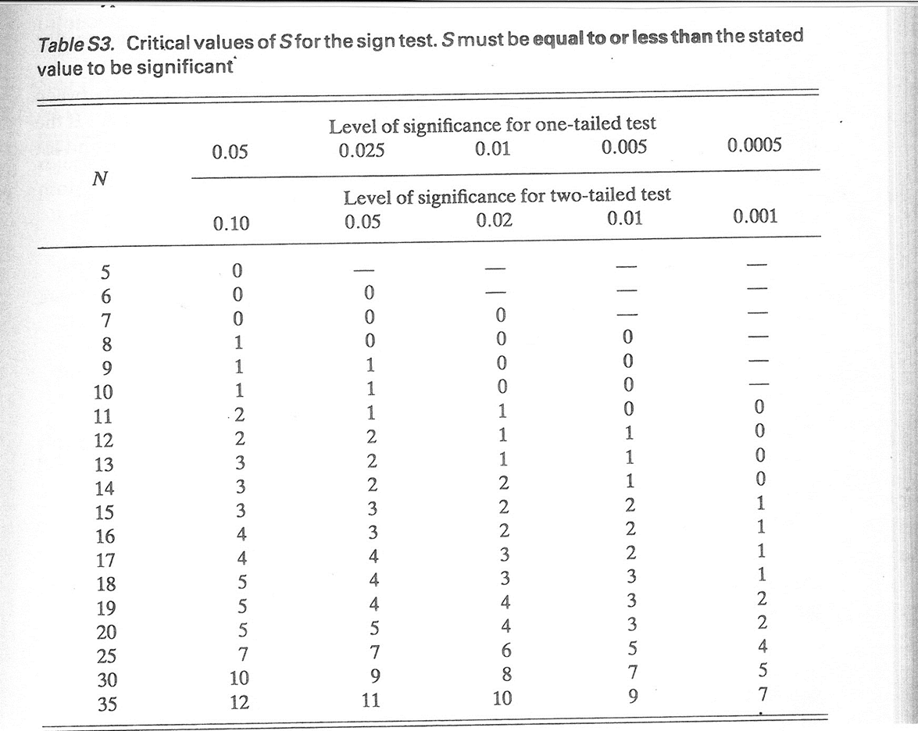

Chi- Square Test X²

This test compares observed frequencies (those actually obtained) with expected frequencies (the averages which would be observed if the null hypothesis were true).

X² =Σ (O-E)2 O = Observed Values E = Expected values
E

Example: - Piaget Conservation Experiment
Hypothesis: 7 year olds will be more likely to be able to conserve than 5 year olds. (Directional - One-tailed)

Data must be first entered into a contingency table: -

 | Number able to conserve | Number unable to conserve | Row Total (RT)
5 year olds | 8 ¹ | 12 ² | 20
7 year olds | 17 ³ | 3 ⁴ | 20
Column Total (CT) | 25 | 15 | GT = 40

Degrees of freedom = (No: of rows -1)(No: of columns – 1)
df = 1x1 = 1

Expected values = RT x CT
GT
Expected Value Cell 1 = 20 X 25 = 12.5
40
Expected Value Cell 2 = 20 X 15 = 7.5
40
Expected Value Cell 3 = 20 X 25 = 12.5
40
Expected Value Cell 4 = 20 X 15 = 7.5
40
 | o | e | o-e | (o-e)² | (o-e)²  e
Cell 1 | 8 | 12.5 | -4.5 | 20.25 | 1.62
Cell 2 | 12 | 7.5 | 4.5 | 20.25 | 2.7
Cell 3 | 17 | 12.5 | -4.5 | 20.25 | 1.62
Cell 4 | 3 | 7.5 | 4.5 | 20.25 | 2.7
 |  |  |  |  | Σ = 8.64

Calculated Value = 8.64

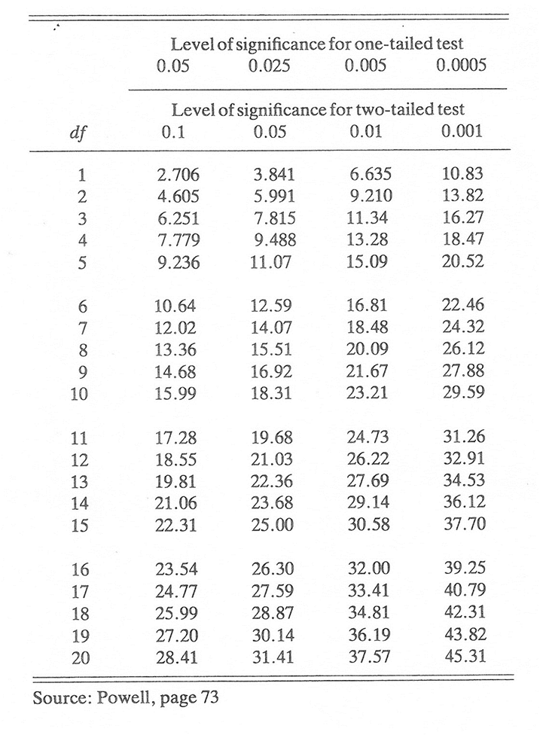
Critical value for a one tailed test, 1 df at 5% = 2.706, therefore the result is significant, the null hypothesis can be rejected. It would appear that 7 year olds are more likely to be able to conserve than 5 year olds.

Mann Whitney U Test

Hypothesis: - Males will score higher on an aggression questionnaire than females. (directional – one-tailed).

Male Scores | Female Scores
25 | 14
17 | 13
16 | 12
10 | 18
12 | 11
18 | 9
16 | 10
17 | 16
15 | 15
14 | 11
Mean = 16 | Mean = 12.9

Formula U = N₁ N₂ + N₁ (N₁ +1) - T
2
Rank all your data together: -

9 | 10 | 10 | 11 | 11 | 12 |  | 12 | 13 | 14 | 14 | 15 |  | 15 | 16 | 16 | 16 | 17 |  | 17 | 18 | 18 | 25
1 | 2 | 3 | 4 | 5 | 6 |  | 7 | 8 | 9 | 10 | 11 |  | 12 | 13 | 14 | 15 | 16 |  | 17 | 18 | 19 | 20
1 | 2.5 | 2.5 | 4.5 | 4.5 | 6.5 |  | 6.5 | 8 | 9.5 | 9.5 | 11.5 |  | 11.5 | 14 | 14 | 14 | 16.5 |  | 16.5 | 18.5 | 18.5 | 20
Male Scores |  |  |  |  |  | Ranks |  |  |  |  |  | Female Scores |  |  |  |  |  | Ranks
25 |  |  |  |  |  | 20 |  |  |  |  |  | 14 |  |  |  |  |  | 9.5
17 |  |  |  |  |  | 16.5 |  |  |  |  |  | 13 |  |  |  |  |  | 8
16 |  |  |  |  |  | 14 |  |  |  |  |  | 12 |  |  |  |  |  | 6.5
10 |  |  |  |  |  | 2.5 |  |  |  |  |  | 18 |  |  |  |  |  | 18.5
12 |  |  |  |  |  | 6.5 |  |  |  |  |  | 11 |  |  |  |  |  | 4.5
18 |  |  |  |  |  | 18.5 |  |  |  |  |  | 9 |  |  |  |  |  | 1
16 |  |  |  |  |  | 14 |  |  |  |  |  | 10 |  |  |  |  |  | 2.5
17 |  |  |  |  |  | 16.5 |  |  |  |  |  | 16 |  |  |  |  |  | 14
15 |  |  |  |  |  | 11.5 |  |  |  |  |  | 15 |  |  |  |  |  | 11.5
14 |  |  |  |  |  | 9.5 |  |  |  |  |  | 11 |  |  |  |  |  | 4.5
 |  |  |  |  |  | T = 129.5 |  |  |  |  |  |  |  |  |  |  |  | T = 80.5

U¹ = 10 X 10 + 10(10 +1) - 129.5
2
U¹ = 100+ 110 – 129.5
2
U¹= 155-129.5 = 25.5

U² = 10 X 10 + 10(10 +1) - 80.5
2
U² = 100+ 110 – 80.5
2
U² = 155-80.5 = 74.5

Select whichever U value is the smaller as your calculated value, in this case U¹ = 25.5

The critical value for a one-tailed test at 5% N = 10 is 27, therefore the result is significant and it is necessary to reject the null hypothesis. Evidence has been discovered to suggest that males did score higher on an aggression questionnaire than females.

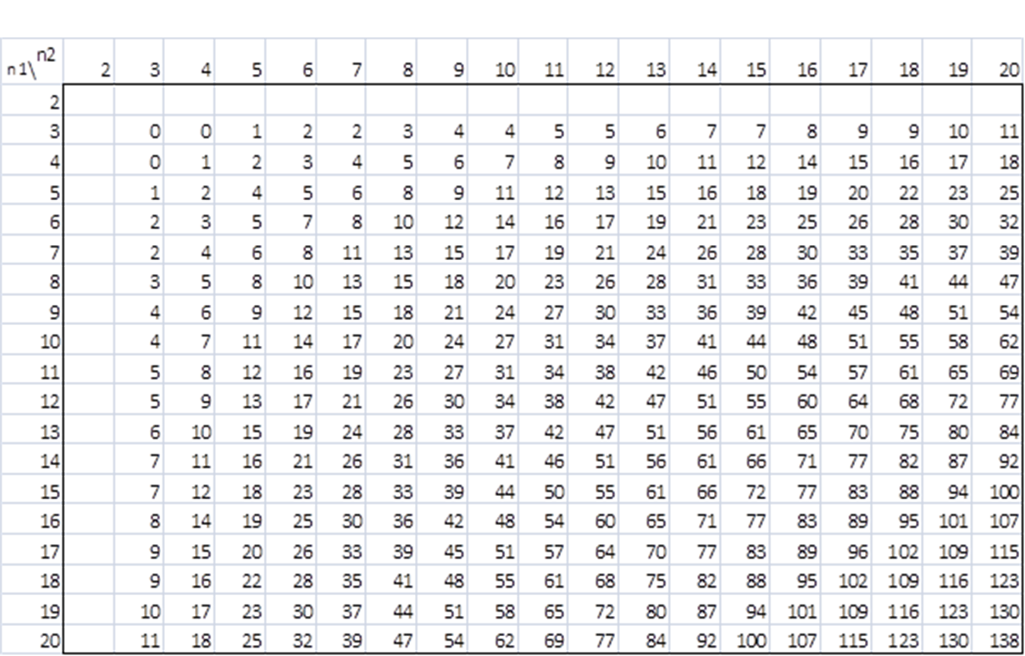
The Wilcoxen Matched Pairs Signed Ranks Test

Hypothesis: Participants will score lower on a reaction test after consuming alcohol. (Directional – one-tailed)

Before Alcohol score | After Alcohol score | Difference | Rank
20 | 17 | 3 | 6
14 | 12 | 2 | 7.5
14 | 16 | -2 | 7.5
19 | 12 | 7 | 1
15 | 16 | -1 | 9
19 | 14 | 5 | 4
13 | 13 | 0 | Omitted
16 | 11 | 5 | 4
19 | 13 | 6 | 2
16 | 11 | 5 | 4

Rank the differences ignoring the signs, giving the highest difference rank 1

1 | 2 | 2 | 3 | 5 | 5 | 5 | 6 | 7
1 | 2 | 3 | 4 | 5 | 6 | 7 | 8 | 9
9 | 7.5 | 7.5 | 6 | 4 | 4 | 4 | 2 | 1

Sum of ranks with + = 28.5
Sum of ranks with - = 16.5

The lowest value is T, your calculated value.

Calculated Value = 16.5

Critical value for a one tailed test at 5%, N = 9 (no difference scores are omitted) = 8
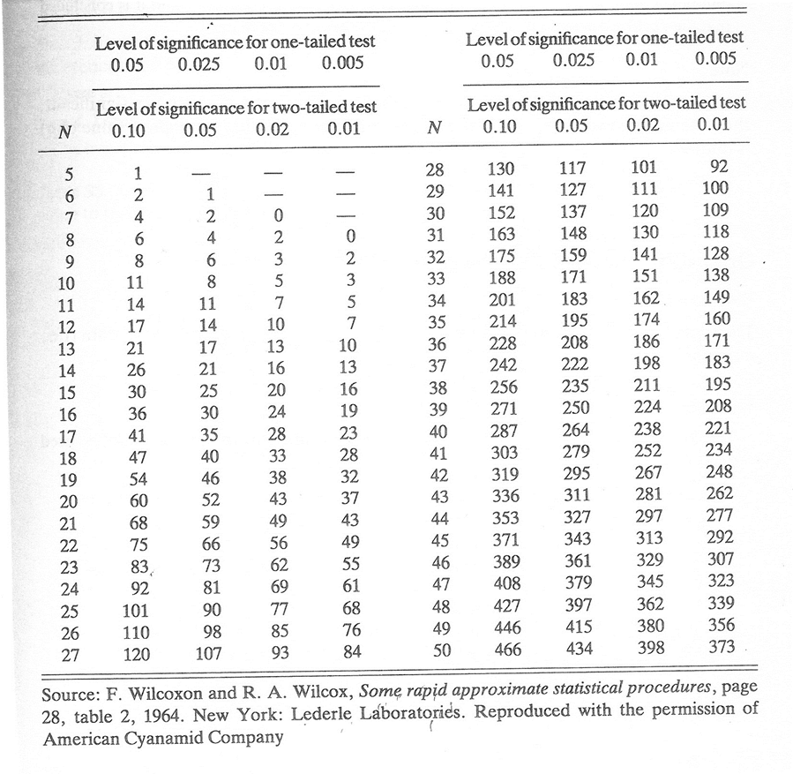
There the result is NOT significant, the null hypothesis must be accepted ted as NO evidence has been found to support the view that alcohol effects reaction times.

Decide which test is appropriate in the following scenarios. You need to think about whether it is a test of difference or association, the type of date (ordinal or nominal) and the experimental design (independent, repeated, matched pairs or correlation)

- An experiment predicting that female IQ scores on a standard IQ test will be higher than males.

Difference or Association: -

Experimental Design: -

Type of Data:

Test:

- An analysis of the relationship between happiness and self-esteem, predicting that the higher a person’s rated their own self-esteem, the higher they would rate their happiness.

Difference or Association: -

Experimental Design: -

Type of Data:

Test:

- An observation of driver behaviour to test that more males than females stop at zebra crossings for pedestrians.

Difference or Association: -

Experimental Design: -

Type of Data:

Test:

- Males will spend more time watching TV than females.

Difference or Association: -

Experimental Design: -

Type of Data:

Test:

- A survey of students expecting to find that those with internet access estimate time spent on homework to be greater than those with no internet access.

Difference or Association: -

Experimental Design: -

Type of Data:

Test:

- Satisfaction levels among students over the course of a college day predicting that students will report higher satisfaction ratings after lunch than before.

Difference or Association: -

Experimental Design: -

Type of Data:

Test:

- A piece of research being conducted in a hospital out-patient department expecting to find that blood pressure goes up as waiting time increases.

Difference or Association: -

Experimental Design: -

Type of Data:

Test:

- A cohort study of identical twins predicting that they will have very similar IQ test scores as measured by standardised IQ tests.

Difference or Association: -

Experimental Design: -

Type of Data:

Test:

- A piece on biopsychological research predicting that asthma sufferers will score higher on anxiety scales than people who do not have asthma.

Difference or Association: -

Experimental Design: -

Type of Data:

Test:

- Research conducted in an eating disorder clinic aiming to show bulimics will demonstrate food preferences for saltier snacks, while anorexics will demonstrate preferences for sweeter snacks.

Difference or Association: -

Experimental Design: -

Type of Data:

Test:

- A survey of gender and self-esteem predicting that males have higher self-esteem than females.

Difference or Association: -

Experimental Design: -

Type of Data:

Test:

- An observational piece of research on gender and pro-social behaviour predicting that females are more likely to give up their seat on a crowded bus.

Difference or Association: -

Experimental Design: -

Type of Data:

Test:

- A research project conducted by the ministry of Defence to assess the effects of anxiety on active service, predicting that soldiers will score higher on anxiety scales on their return from active service than before active service.

Difference or Association: -

Experimental Design: -

Type of Data:

Test:

- Fathers are more likely than mothers to report feelings of euphoria at the birth of their first child.

Difference or Association: -

Experimental Design: -

Type of Data:

Test:

- Mothers are more likely than fathers to report feelings of panic on learning that they are to become parents of twins.

Difference or Association: -

Experimental Design: -

Type of Data:

Test:

- Women over 40 are more likely than those under 40 to show symptoms of decorxeria (an obsessive relationship with décor and home furnishing, prevalent in female psychology teachers!)

Difference or Association: -

Experimental Design: -

Type of Data:

Test:

- A study to discover if lesson observation ratings (outstanding, good, requires improvement, inadequate) between teachers working in the same department are very similar.

Difference or Association: -

Experimental Design: -

Type of Data:

Test:

- Identical twins take part in an experiment on the effects of sleep deprivation on memory. One twin is in the experimental group (deprived of one night’s sleep), the other the control (normal night’s sleep). The next day they given a memory test, the maximum possible score is 25.

Difference or Association: -

Experimental Design: -

Type of Data:

Test:

- Participants take part in an experiment on the effects of sleep deprivation on memory. Half the participants are allowed to sleep, the other half are kept awake. The next day they given a memory test, the maximum possible score is 25.

Difference or Association: -

Experimental Design: -

Type of Data:

Test:

- It is expected that older women (over 40) will choose a larger body shape silhouette as their ideal than younger women (under 20). All participants are given a questionnaire with 5 different body shapes (ranging from size 8 -16) on and are asked to choose their ideal shape.

Difference or Association: -

Experimental Design: -

Type of Data:

Test:

- It is expected that the amount of rainfall is related to the sales of umbrellas.

Difference or Association: -

Experimental Design: -

Type of Data:

Test:

- A group of people are asked whether or not they are in favour of animal experimentation. They are then shown a film on the subject and asked again.

Difference or Association: -

Experimental Design: -

Type of Data:

Test:

Parametric Tests

Conditions for Parametric Testing: -

- Data is interval or ratio
- Data is normally distributed
- Standard deviations (variances) for the two sets of data are similar

Data | Test of Difference |  | Test of Association
 | Independent Measures | Repeated Measures/Matched Pairs
Interval/Ratio | Unrelated t-test | Related t-test | Pearson’s

Features of Science: Psychology as a Science

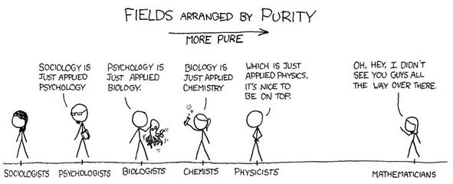

What is Science?

The word Science comes from the Latin word scientia meaning knowledge. Therefore using this narrow definition psychology is definitely a science as it is all about gaining knowledge of human behavior through the scientific method.
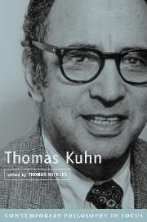
According to the American philosopher Thomas Kuhn, a science should have a shared set of: -

- Assumptions
- Scientific methods
- Terminology

Whilst psychology is clearly succeeding in b) and c), we use the scientific method by setting up experiments to test our hypotheses and we do have specialist vocabulary, a) is slightly more contentious.

The fact that within psychology there are conflicting explanations and assumptions about human behavior has led some to label psychology as unscientific. However, this is an unfair critique as there are conflicting opinions and assumptions in the natural sciences too. Also, Psychology is a relatively young science and still testing and refining theories. Remember: - No theory in science is final.

A science should provide precise (operationalised) hypotheses which can be tested in order to support or refute a theory.

Psychology does try to aspire to this goal, however, some aspect of human behavior and cognition are not so easy to define (operationalise) For example, it is difficult to be precise about things such as intelligence as there is no agreed upon definition of exactly what intelligence is.

Falsification

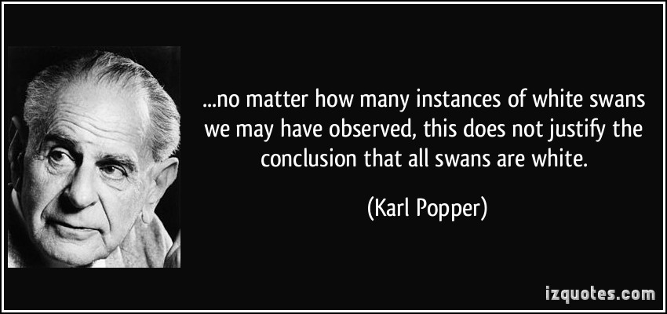

Falsification does not mean something is false; rather that if it is false, then this can be shown by observation or experimentation. Karl Popper famously inferred in the quote above that ‘All swans are white’ can be falsified by observing just one black swan. Therefore true science should be able to not only show that the data is true but also that it can be shown to be untrue.

One of the main theorists lacking scientific objectivity is Freud. It may be difficult to provide evidence to support his theories, but it is equally impossible to falsify them too!

Predictive power

Theories should provide general laws or principles to allow predictions of future behavior. Many theories in psychology do take a nomothetic (apply to the whole population) approach, but some take an idiographic (apply to individuals or small groups) approach, such as the Individual differences approach. These approaches are just as valuable to our understanding of human behavior. In fact it is the differences between individuals which make psychology so fascinating.

Scientific Paradigms

Thomas Kuhn argues that the social sciences are fundamentally different to the physical sciences. He is suggesting that psychology belongs in the social science grouping (which is contentious). Kuhn argues that the physical sciences could hold one unifying theory or paradigm (the world is flat) which may then shift when new evidence is discovered (the world is round). However, he argues that this cannot apply to the social sciences as there is not one unifying theory upon which we could test our ideas.

Behaviorism was once seen as a possible unifying theory for psychology, it was popular for its scientific simplicity; simple laws of cause and effect. However, it is far too simplistic to explain the complex phenomenon which is human behavior. Likewise biological theories are considered reductionist. In reality, it is the complex interaction between nature and nurture which is required to understand human behavior. The unique human attribute of free will means that studying human behavior will never be straightforward or easy, but it is infinitely more interesting.

Ethical Considerations

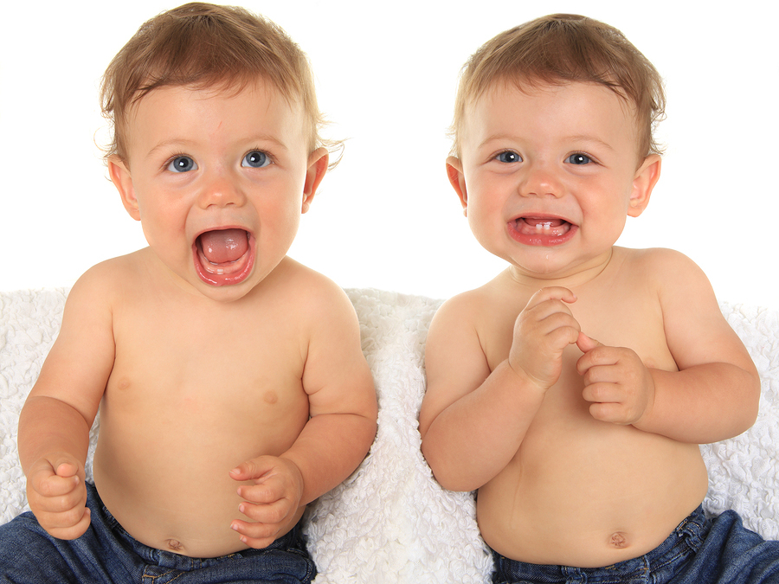
A further obstacle in the path of scientific objectivity is ethical dilemma. We cannot isolate and test variables without being cruel or unethical. For example, the only way to scientifically test the nature/nurture debate would be to isolate identical twins and raise them in completely different environments!!!

Animals have been used where humans can’t be to overcome some ethical issues. However, we cannot necessarily apply the findings from animal research to humans, we are very different.

Task: Do you think Psychology is a science? What is the evidence for and against? Use studies as evidence to illustrate your answer.

Reporting Psychological Investigations

Investigations must be written up in the style of a scientific report. All the pages must be numbered and must be written in the third person passive. This means in the past tense and don’t say ‘I’ or ‘we’.

It must be concise and precise, this is good scientific practice and you will be under time pressure in the examination.

Reports must include the following sections in this precise order: -

Title, Content page, Abstract, Introduction, Procedure, Results, Discussion, References, Appendices



Title

This must be concise and to the point, yet clear enough to give the reader an idea of the investigation’s central concerns.

Contents Page

Every page must be numbered and every section must be recorded along with the page number on the contents page.

Abstract

This is a brief summary of the entire investigation (100-150 words maximum) and is actually written last, although it appears at the beginning of the report.
You need to include: -
- A one-sentence summary, giving the topic to be studied (aim and main background study)
- Description of participants and sampling technique
- Description of procedure
- Description of results (quote statistics and significance level)
- What does it mean? Conclusion, implications and suggestions for future research.

Introduction

In this section you review all the background research relevant to your investigation. You must clearly quote your aim and operationalised hypothesis and null hypothesis. E.g. Males will score higher on an aggression questionnaire than females. (One-tailed) Any difference between male and female scores on an aggression questionnaire will be due to chance.

- Review of background research
- Aim
- Hypothesis and null hypothesis

Procedure

This section has four sub-sections, each should be sub-titled. The aim is to produce a sufficiently detailed method for someone to be able to exactly replicate your study.

Design and overview

State what research method you are using and why. The choice of research design (independent measures, repeated measures, matched pairs or correlation) should also be stated and justified. If your experiment is an experiment state the operationalised IV and DV. Also mention any other variables that you have controlled such as gender or age and any confounding variables you were unable to control i.e. individual differences, situation etc. Explain how you will deal with ethical issues. Remember not to use any participants under the age of 16. You must ensure that you have informed consent, protect them from harm, give your participants the right to withdraw, keep their details confidential, debrief them etc.

- Research method
- Research Design
- Variables
- Controls
- Ethics

Participants & investigators

Who were your participants and how did you select them. You need to describe your sampling procedure and give relevant details such as age, gender, social class and educational background etc. about your participants, whilst ensuring they remain anonymous. You will probably use an opportunity sample selected from your own college, do not even give the name of the college, and instead say ‘a local 6th form’. If you have more than one condition in your investigation, explain how participants were allocated to conditions, this might be obvious if the IV was age or gender. For ethical reasons do not use anyone under 16, as you would require parental consent.

- Investigator (s) – Just yourself or a small group (names)?
- Number of participants and anonymous details
- Sampling procedure
- Number in each condition and how they were allocated
Apparatus

A list of everything you used as part of your investigation. Refer to copies of any materials in appendices.
Procedure

This needs to explain exactly what you did from start to finish, including any pilot studies, design of stimulus material etc. Remember to refer the reader to the appendices for standardised instructions, debrief, copies of stimulus materials etc.

Results

Descriptive results aim to be as clear and precise as possible. A summary table of results should be presented, along with appropriate, fully labelled graphs. However, be careful with graphs, one is usually enough, the important thing is clarity. Make sure you provide a paragraph underneath your table and graph that fully explains what they show. Do not include raw data here – refer the reader to the appendices.

e.g.
Summary Table of Results – Table to show average scores on an aggression questionnaire of males and females.

 | Males | Females
Mean | 20.6 | 14.3
Standard Deviation | 3.1 | 4.1

This shows on average that………
The variation in male and female aggression scores shows that…….
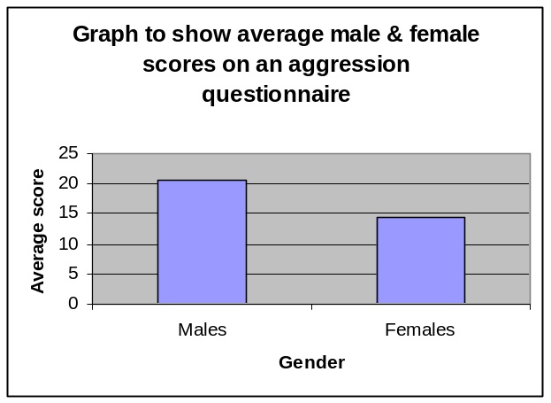
The graph shows that…………

Analysis of results

This is where you present the results of your inferential statistics. In other words were your results statistically significant – Is it possible to reject the null hypothesis? Your statistical test must be fully justified with reference to the data and your results quoted in terms of reject/accept the null hypothesis. All calculations and critical value tables should be included in the appendices (This means the computer printouts of your results).

To recap: -

Choosing an appropriate statistical test

 | Test of Difference |  | Test of Association
Level of Measurement | Independent Measures Design | Repeated Measures Design or Matched Pairs | Correlation
Nominal (Frequency) | Chi-square | Sign Test | Chi-Square
Ordinal, Interval or Ratio (Ranked) | Mann-Whitney U Test | Wilcoxon matched pairs signed ranks test | Spearman’s Rank Order Correlation Coefficient

E.g. This investigation was a test of difference and utilised an independent measures design because a difference between two groups (males and females) was being looked for. The questionnaires generated ordinal data in the form of scores, so the appropriate statistical test was the Mann Whitney U Test. After calculation U = 18 (see appendices Pg…. for calculations), the critical value for a one tailed test at 5% = 27. The result was statistically significant and therefore it was necessary to reject the null hypothesis that any difference between male and female scores on an aggression questionnaire was due to chance.

- Summary table
- Graphs
- Descriptions of table and graphs
- Justification of statistical test
- Results quoted in terms of null hypothesis

Discussion
Explanation of findings

In the results section you stated your findings in statistical terms. Now state them in psychological terms, relating the finding to your initial aims/hypothesis. Also state whether or not your findings support those of your background study. You may have additional findings to report aside from those related to the hypotheses, such as observations made when collecting data.
In this section you need to explain in non-statistical language exactly what you found and what it means. Comment on the strength of the relationship or effect you discovered, for example were your results only just significant or not or was it a very strong effect. If the results went in totally the opposite direction to what you were expecting, comment on this too. Finally, briefly explain why you think you found what you did. Never, ever, use the words prove or disprove, instead say you found evidence to suggest, support etc.

- What did you find?
- Why?
- What does it mean?

Limitations and modifications

Take a critical look at your own research. What went really well, what were the strengths? What was wrong with it- if you were to do it again what would you do differently? Be honest here – it is more important to show an awareness of weaknesses than produce a perfect piece of research. Remember to pay particular attention to confounding variables that could have affected your results and sampling size/technique. When suggesting modifications it is not necessary to be constrained by practical concerns such as time and money because this is what you would do in a perfect world!

- Strengths
- Weaknesses
- Modifications (things to change if repeated)

Implications and suggestions for further research

The last section of the discussion deals with the implications, applications of your research and ideas for future research. How relevant are your results to the real world? What practical applications do they have? For example, if you did a memory experiment your findings could be relevant to education, examination revision and generally to improving memory. Eyewitness testimony research has important implications for criminal justice.
You should try to suggest some ideas for further research, but note these should be different to the modification you suggested in the previous section. The great thing here is you don’t have to worry about mundane practicalities, as you are not going to actually carry out the research, so it is quite acceptable to suggest a 20 year longitudinal study or a cross-cultural comparison etc.

- Real world applications and implications
- Further research

References

Your background study should be referenced, as should any internet resources such as psychometric tests, questionnaires etc., these should include date accessed as well as website address.

e.g.
Bandura A, Ross D & Ross S (1961) Transmission of aggression through imitation of aggressive models Journal of Abnormal & Social Psychology 63: 375-382
All references should be alphabetical order.

Task: -
Write the following references in the correct order: -
London | Duck, S | Sage | (1992) | Human Relationships
Cambridge | Gajic, D | Illuminate | (2018) | Secrets of a Psychology Teacher
pgs 671-684 | (1972) | Craik & Lockhart |  | Levels of Processing Journal of Verbal Learning & Verbal Behaviour 11
Academic Press | New York | R L Selman | (1980) | The growth of interpersonal understanding: developmental and clinical analyses
(1993) | S Bem | New Haven | Yale University Press | The lenses of gender: transforming the debate on sexual inequality

Appendices

Any additional information such as raw data, statistical calculations, stimulus material, standardised instructions and debrief etc. Each appendix should be numbered, have a full title and be referred to somewhere in the main body of the report.

